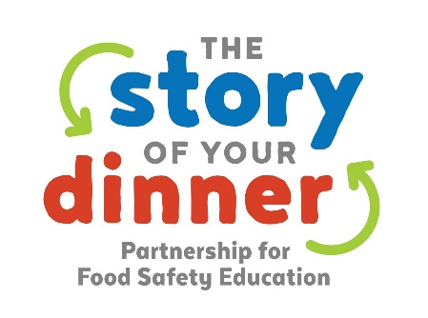
.
Template press release – personalize this for your local media outreach!
For Immediate Release
Contact: YOUR NAME
PHONE NUMBER
EMAIL ADDRESS

“The Story of Your Dinner” Offers New Recipes to Cure Home Cooking Fatigue
Your Organization Name and the Partnership for Food Safety Education team up to increase consumer awareness of home food safety basics among families

Your City/State (Date) — Food safety is the foundation of every delicious meal. To support home cooks in getting a safe meal on the family dinner table, Your Organization is working with the Partnership for Food Safety Education on The Story of Your Dinner campaign during National Food Safety Education Month and the hectic holiday season.

“We understand the importance of food safety education and are thrilled to work alongside the other partners in sharing important messages, useful information and ultimately, reducing foodborne illness,” said Your Organization Spokesperson - feel free to customize.

Now in its fifth year, The Story of Your Dinner campaign highlights the importance and ease of food safety for families and young children. The Story of Your Dinner campaign includes free, shareable materials for consumers, the food industry and the Partnership’s active network of 13,000 BAC Fighters. These BAC Fighters are health and food safety educators — including dietitians, cooperative extension specialists, caregivers, and public health officials — who deliver food safety education to millions of people in the United States each year.
The Partnership launched the Safe Recipe Cookbook, which features 10 recipes unlike those usually found online. These 30-minute meals that were entered in a summer contest by health and food safety communicators, food bloggers, and kids who care about food safety. All recipes entered in the contest were built using the Safe Recipe Style Guide.
Other just-released home food safety items available through The Story of Your Dinner include a short video for parents “Your Baby & Food Safety” — available in English and Spanish — activity sheets for kids, and many other resources to help ensure food safety in your kitchen now and throughout the holiday season.
Materials designed to educate and engage families on safe food preparation, include:
- Live action video “Your Baby & Food Safety“
- Safe Recipe Cookbook with contest-winning recipes
- Animated video to “Keep a Clean Scene” at home when preparing meals
- Animated video on the food safety chain of prevention
- Shareable recipe videos and printable recipe cards
- Infographic on risks of raw batter/dough and baking food safety
- Safe Recipe Activity for Middle School Students
- Activity sheets and coloring placemats for kids
For more information and safe food handling tips, visit StoryOfYourDinner.org and follow the non-profit Partnership for Food Safety Education (Facebook: @FightBAC, Twitter: @FightBAC), and Your Organization on social media throughout the season.
Thanks to The Story of Your Dinner Campaign Sponsors
Campaign sponsors, who demonstrate a collective commitment to engaging Americans on the importance of food safety, include Cargill, Costco Wholesale and the FMI Foundation.
About the Partnership for Food Safety Education
The non-profit Partnership for Food Safety Education is the originator of science-based food safety messages and the national leader in developing and disseminating information around the linkage of food safety consumer education with positive health outcomes. Food safety and health educators, and consumers, can download free food safety education information from the Partnership’s website at www.fightbac.org. The Partnership is the creator and steward of the popular Fight BAC!® national food safety education campaign.
###

